

**Agri_Market-linker Rwanda**

An agriculture market linker Rwanda is a platform that helps farmers and other agriculture professionals to manage and optimize their farming operations. Rwanda is among largest agriculture sector in the Eastern Africa. Agriculture sector provides employment to over two third population of the country. The Agriculture Market Project provides its users and researches to get online information about, the crop, statistical details and new tendencies. This project is aimed at solving some of the major problems related to farmers. The web interface has been designed completely user friendly, to facilitate the access even to an illiterate farmer.

The main objective of developing “Agri_Mrket-linker Project” application is to help farmers by providing all kinds agriculture related information in the website. Agriculture Management System is farmer management website application which helps farmers to give best-practice farming processes. It helps farmers to improve their productivity and profitability. It enables farmers to sell their products online and farmers can purchase tools and seeds directly from seller. Farmers can view labors profile and they can hire labors. An agriculture market is a platform that helps farmers and other agriculture professionals to manage and optimize their farming operations.

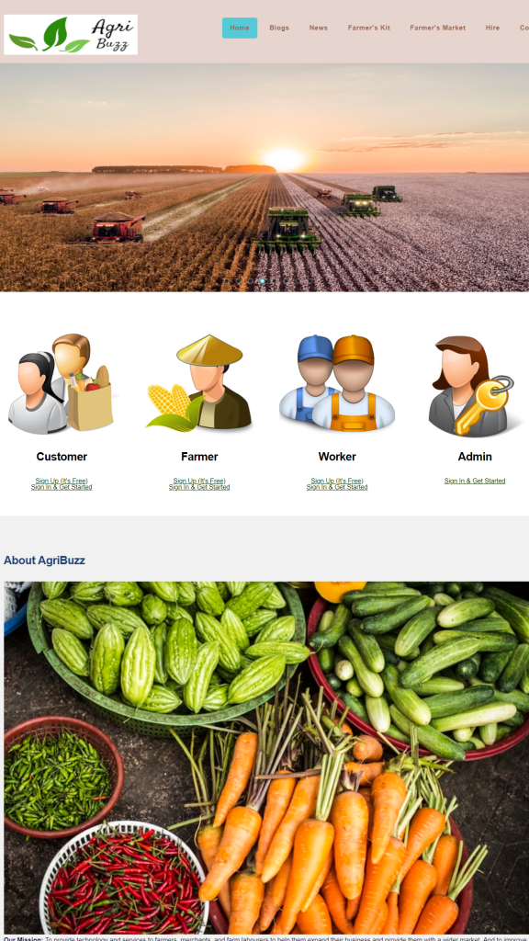

**This product has following features:**

* The farmers can sell their productions online and the buyer can purchase various agricultural products online.  Buyer can send purchase request to check the quality of the product.
* After collecting all the farm produce from the farmers, it should be sold to the wholesaler/retailer. This module covers these entries and the charge details also should be entered. The Payments will be received from the wholesaler/retailer once the product delivered to them.
* There are 4 types of users: Customer, Farmers, Workers, and Administrator. The login id and password must be required to login the system.
* The Training section helps farmers to improve their productivity and profitability.
* Administrator can view and print all kinds of reports.

**Software Interfaces:**